|  |  |  |
| --- | --- | --- |
| Zip | | |
| Input | Process | Output |
| Have the user input there zip code | Get the first 3 numbers compare them with the shipping amount | Show the shipping cost |

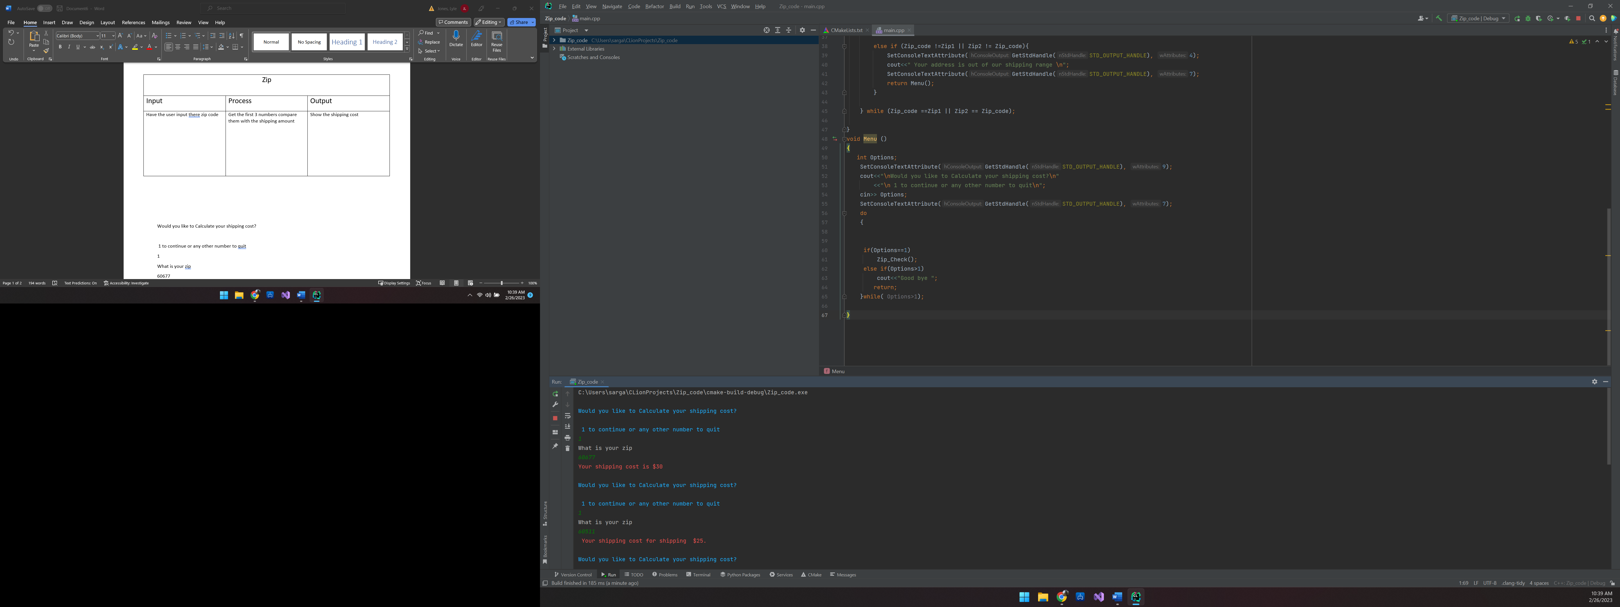

Would you like to Calculate your shipping cost?

1 to continue or any other number to quit

1

What is your zip

60677

Your shipping cost is $30

Would you like to Calculate your shipping cost?

1 to continue or any other number to quit

1

What is your zip

60511

Your shipping cost for shipping $25.

Would you like to Calculate your shipping cost?

1 to continue or any other number to quit

1

What is your zip

60344

Your address is out of our shipping range

Would you like to Calculate your shipping cost?

1 to continue or any other number to quit

1

What is your zip

7130

Your address is out of our shipping range

Would you like to Calculate your shipping cost?

1 to continue or any other number to quit

1

What is your zip

1

Your address is out of our shipping range

Would you like to Calculate your shipping cost?

1 to continue or any other number to quit

1

|  |  |  |
| --- | --- | --- |
| Color | | |
| Input | Process | Output |
| Have the customer put the product number in | Get the 4th number for the input and  If the 4th number or letter is correct then it will match to the color | Shows the color the camera is coming in and show matching color |

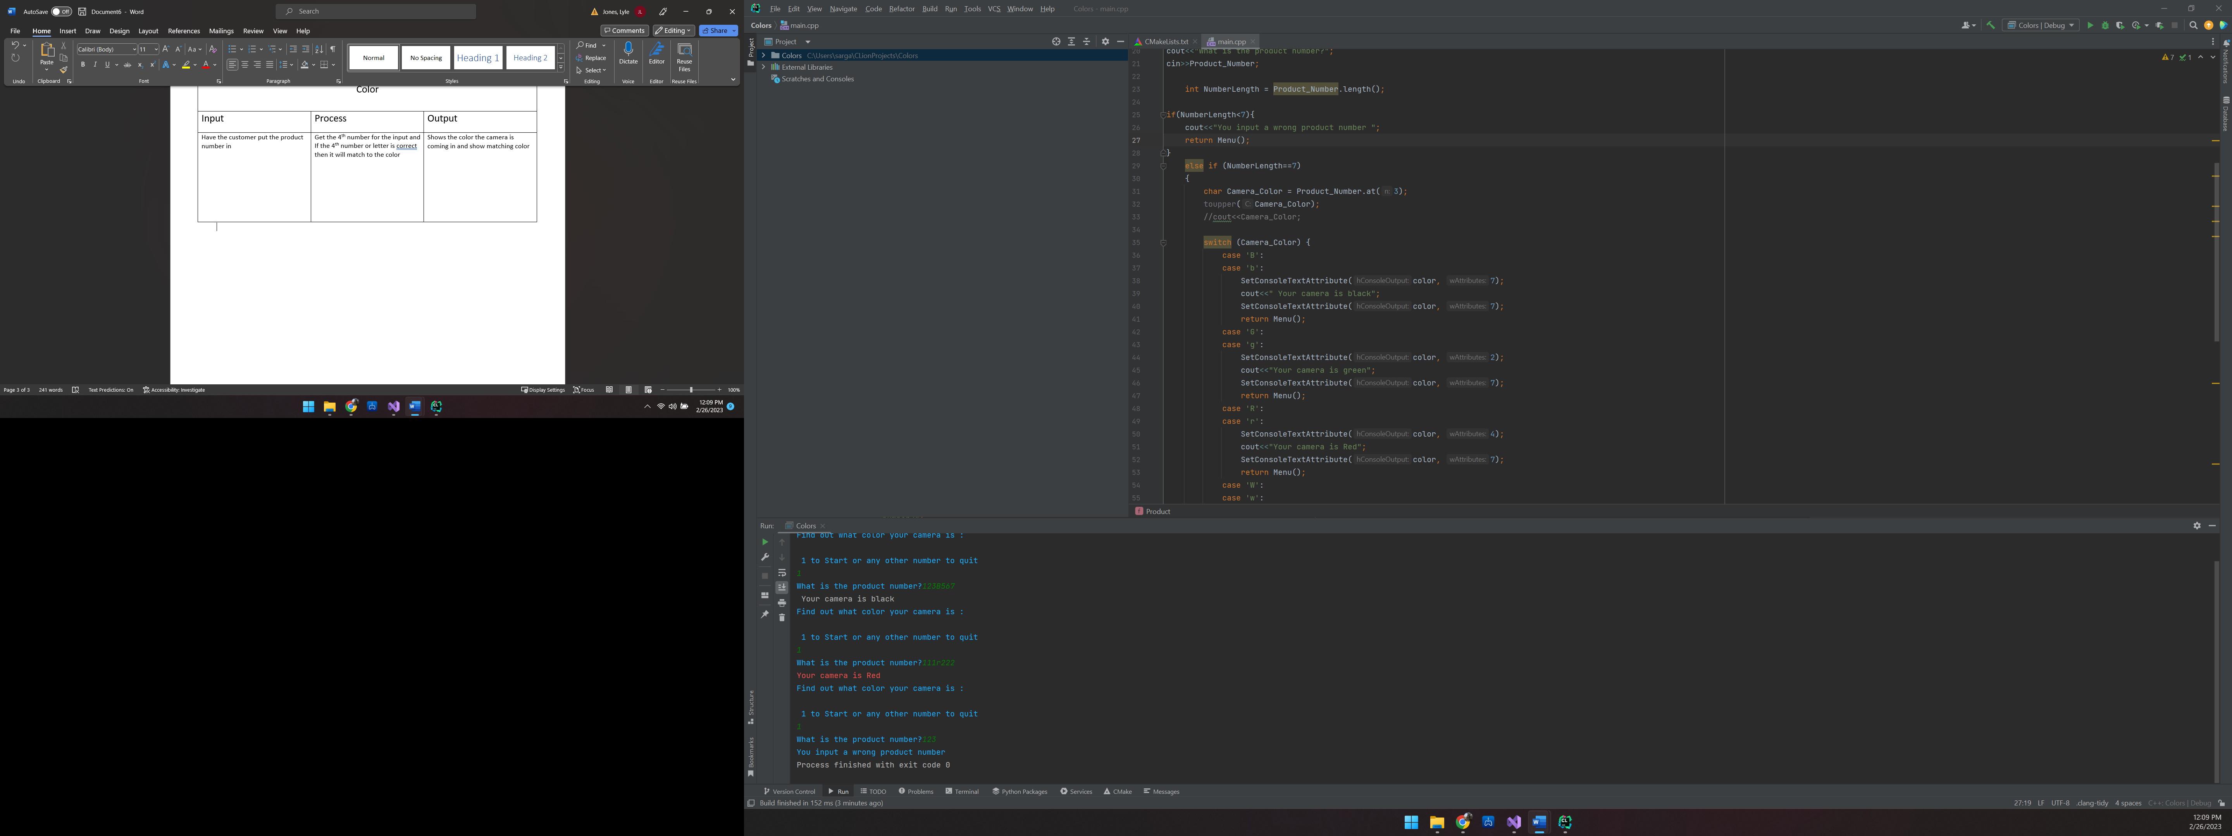

Find out what color your camera is :

1 to Start or any other number to quit

1

What is the product number?123B567

Your camera is black

Find out what color your camera is :

1 to Start or any other number to quit

1

What is the product number?111r222

Your camera is Red

Find out what color your camera is :

1 to Start or any other number to quit

1

What is the product number?123

You input a wrong product number

Process finished with exit code 0

#include <iostream>  
#include <string>  
#include <windows.h>  
HANDLE color = GetStdHandle(STD_OUTPUT_HANDLE);  
using namespace std;  
  
  
  
void Product ();  
void Menu ();  
int main() {  
 Menu();  
  
 return 0;  
}  
void Product ()  
{  
  
 string Product_Number;  
cout<<"What is the product number?";  
cin>>Product_Number;  
  
 int NumberLength = Product_Number.length();  
  
if(NumberLength<7){  
 cout<<"You input a wrong product number ";  
 return Menu();  
}  
 else if (NumberLength==7)  
 {  
 char Camera_Color = Product_Number.at(3);  
 toupper(Camera_Color);  
 //cout<<Camera_Color;  
  
 switch (Camera_Color) {  
 case 'B':  
 case 'b':  
 SetConsoleTextAttribute(color, 7);  
 cout<<" Your camera is black";  
 SetConsoleTextAttribute(color, 7);  
 return Menu();  
 case 'G':  
 case 'g':  
 SetConsoleTextAttribute(color, 2);  
 cout<<"Your camera is green";  
 SetConsoleTextAttribute(color, 7);  
 return Menu();  
 case 'R':  
 case 'r':  
 SetConsoleTextAttribute(color, 4);  
 cout<<"Your camera is Red";  
 SetConsoleTextAttribute(color, 7);  
 return Menu();  
 case 'W':  
 case 'w':  
 SetConsoleTextAttribute(color, 15);  
 cout<<" Your camera is white";  
 SetConsoleTextAttribute(color, 7);  
 return Menu();  
 }  
 }  
}  
  
void Menu () {  
 int Options;  
  
 SetConsoleTextAttribute(color, 9);  
 cout << "\nFind out what color your camera is :\n"  
 << "\n 1 to Start or any other number to quit\n";  
 cin >> Options;  
 SetConsoleTextAttribute(color, 9);  
 do {  
  
  
 if (Options == 1)  
 Product();  
 else if (Options > 1)  
 cout << "Good bye ";  
 return;  
 } while (Options > 1);

|  |  |  |
| --- | --- | --- |
| Shipping | | |
| Input | Process | Output |
| Have the customer put the product number in | Get the 2nd and the 3rd number or letter  Check to see if the 2nd and 3rd match | Show the shipping |

Find out what your shipping is :

1 to Start or any other number to quit

1

What is the product number?

7mp6

Your shipping is USPS Mail Priority

Find out what your shipping is :

1 to Start or any other number to quit

1

What is the product number?

3FS5

Your shipping is Fed Ex Standard

Find out what your shipping is :

Find out what your shipping is :

1 to Start or any other number to quit

1

What is the product number?

8ko89

Your number is not correct

Find out what your shipping is :

1 to Start or any other number to quit

1

What is the product number?

1234ms

You input a wrong product number

Find out what your shipping is :

1 to Start or any other number to quit

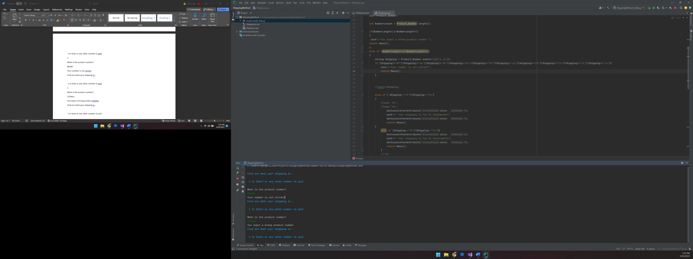

#include <iostream>  
#include <string>  
#include <windows.h>  
  
HANDLE color = GetStdHandle(STD_OUTPUT_HANDLE);  
using namespace std;  
  
void Product ();  
void Menu ();  
  
int main() {  
  
 Menu();  
  
 return 0;  
}  
void Product ()  
{  
  
 string Product_Number;  
 cout<<"What is the product number?\n";  
 cin>>Product_Number;  
  
 int NumberLength = Product_Number.length();  
  
 if(NumberLength<1||NumberLength>5)  
 {  
 cout<<"You input a wrong product number ";  
 return Menu();  
 }  
 else if (NumberLength>=4||NumberLength<=5)  
 {  
 string Shipping = Product_Number.substr(1,2);  
 if (Shipping!="MP"||Shipping!="mp"||Shipping!="MS"||Shipping!="ms"||Shipping!="UP"||Shipping!="up"||Shipping!="FO"||Shipping!="fo"||Shipping!="FS"||Shipping!="fs"){  
 cout<<"Your number is not correct";  
 return Menu();  
 }  
  
  
 //cout<<Shipping;  
  
 else if ( Shipping=="FS"||Shipping=="fs")  
 {  
 //case 'FS':  
 //case 'fs':  
 SetConsoleTextAttribute(color, 7);  
 cout<<" Your shipping is Fed Ex Standard\n";  
 SetConsoleTextAttribute(color, 7);  
 return Menu();  
 }  
 else if (Shipping=="FO"||Shipping=="fo"){  
 SetConsoleTextAttribute(color, 2);  
 cout<<" Your shipping is Fed Ex Overnight\n";  
 SetConsoleTextAttribute(color, 7);  
 return Menu();  
 }  
 //'FO':  
 //case 'fo':  
 else if (Shipping=="UP"||Shipping=="up")  
 {  
 // case 'UP':  
 // case 'up':  
 SetConsoleTextAttribute(color, 7);  
 cout<<" Your shipping is UPS Standard\n";  
 SetConsoleTextAttribute(color, 7);  
 return Menu();  
 }  
 else if (Shipping=="MS"||Shipping=="ms") {  
 //case 'MS':  
 //case 'ms':  
 SetConsoleTextAttribute(color, 7);  
 cout << " Your shipping is USPS Mail Standard\n";  
 SetConsoleTextAttribute(color, 7);  
 return Menu();  
 }  
 else if (Shipping=="MP"||Shipping=="mp") {  
 //case 'MP':  
 //case 'mp':  
 SetConsoleTextAttribute(color, 2);  
 cout << " Your shipping is USPS Mail Priority\n";  
 SetConsoleTextAttribute(color, 7);  
 return Menu();  
 }  
 }  
  
}  
  
  
void Menu () {  
 int Options;  
  
 SetConsoleTextAttribute(color, 9);  
 cout << "\nFind out what your shipping is :\n"  
 << "\n 1 to Start or any other number to quit\n";  
 cin >> Options;  
 SetConsoleTextAttribute(color, 7);  
 do {  
  
  
 if (Options == 1)  
 Product();  
 else if (Options > 1)  
 cout << "Good bye ";  
 return;  
 } while (Options > 1);  
}